**Practical No 1**

**1.1) WAP in C# that ask the user to enter a month, a day and a two-digit year. The program should then determine whether the month times a day is equal to the year. If so, it should display the message saying the date is magic. Otherwise not magic.**

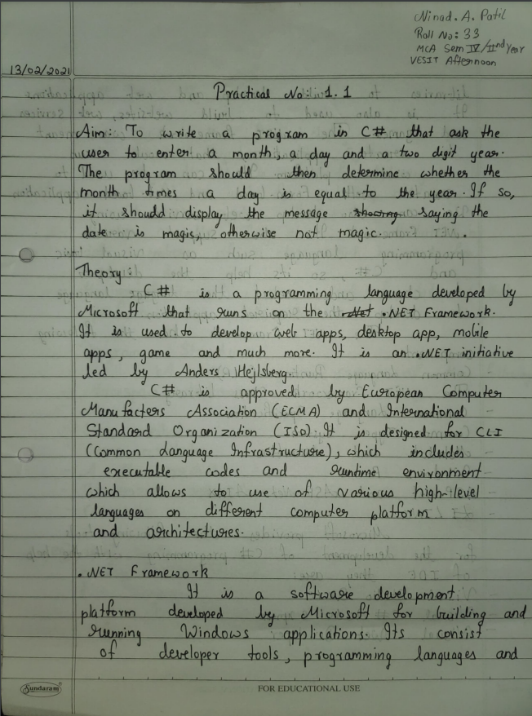

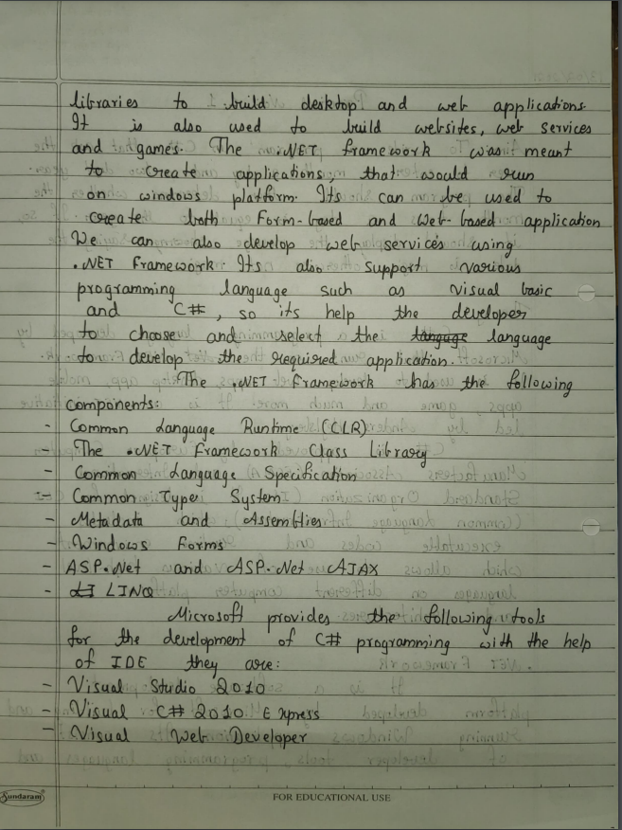

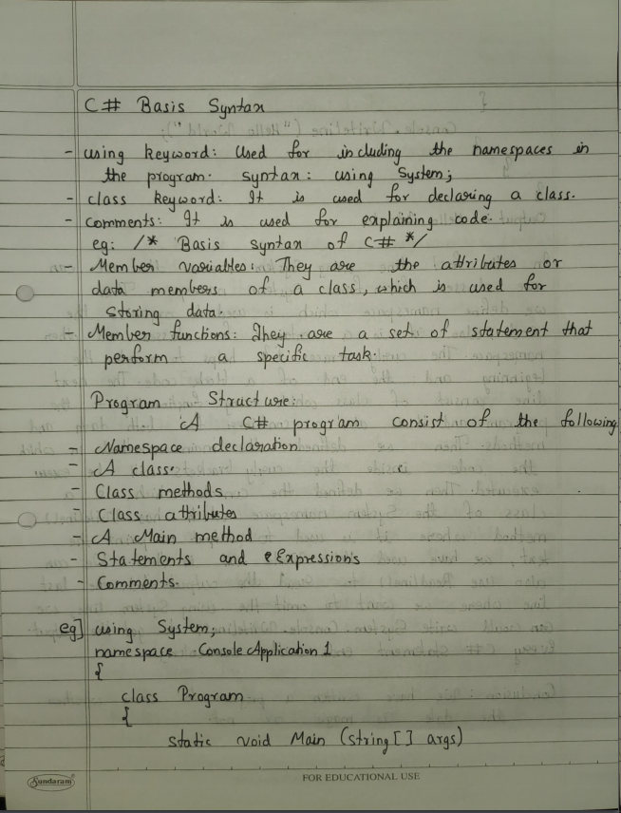

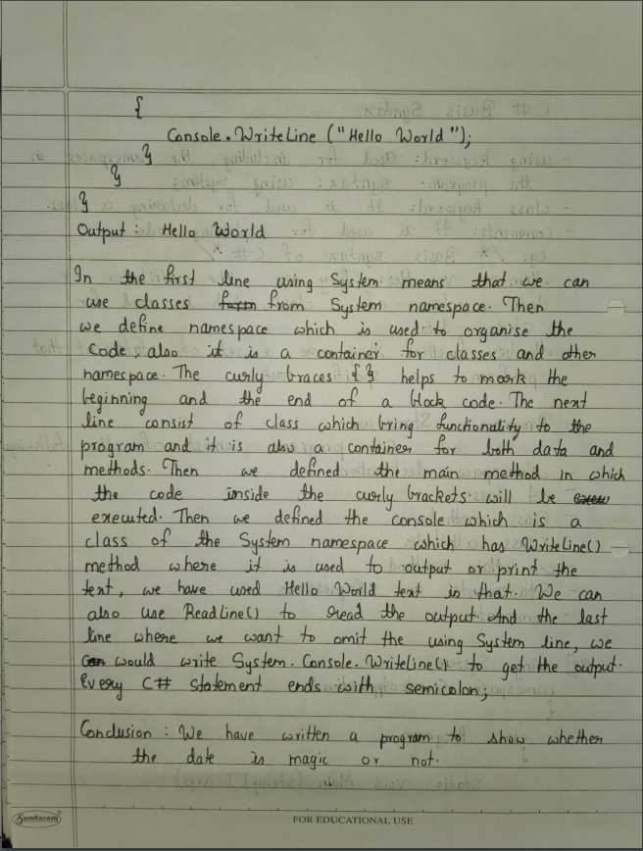

**Code:**

using System;

using System.Collections.Generic;

using System.ComponentModel;

using System.Data;

using System.Drawing;

using System.Linq;

using System.Text;

using System.Windows.Forms;

namespace WindowsFormsApplication1

{

public partial class Form1 : Form

{

public Form1()

{

InitializeComponent();

}

private void label1_Click(object sender, EventArgs e)

{

}

private void button1_Click(object sender, EventArgs e)

{

int day, month, year;

if (int.TryParse(textBox1.Text, out month))

{

if (int.TryParse(textBox2.Text, out day))

{

year = Convert.ToInt32(textBox3.Text);

int result = month * day;

if (result == year)

{

MessageBox.Show("This is a magic date");

}

else

{

MessageBox.Show("This is not a magic date");

}

}

}

}

}

}

**Output:**

